**FLIGHT FINDER PROJECT REPORT**

**1. INTRODUCTION**

**1.1 Project Overview**

The project titled "Flight Finder – Smart Flight Search and Booking System" aims to provide a seamless platform for users to search, compare, and book domestic and international flights. It simplifies the travel booking experience with features such as real-time flight availability, fare comparisons, secure payments, booking management, and notification alerts. Flight operators can manage flight listings, availability, and pricing through a dedicated dashboard, while admins oversee overall system performance and integrity.

This system eliminates the traditional challenges of manual booking and helps users make quicker and more informed travel decisions.

**1.2 Purpose**

The purpose of this project is to provide an intuitive and efficient digital flight booking platform that connects travelers with trusted flight operators. It ensures:

* Easy and fast flight bookings
* Real-time fare and availability tracking
* Personalized user experience with travel history
* Secure and verified payment processing

**2. IDEATION PHASE**

**2.1 Problem Statement**

Travelers face difficulty finding reliable flights due to non-transparent fare systems, outdated booking interfaces, and lack of real-time updates on availability.

How Might We:  
How might we help users search and book the best flights based on real-time prices, timing, and preferences?

**2.2 Empathy Map Canvas**

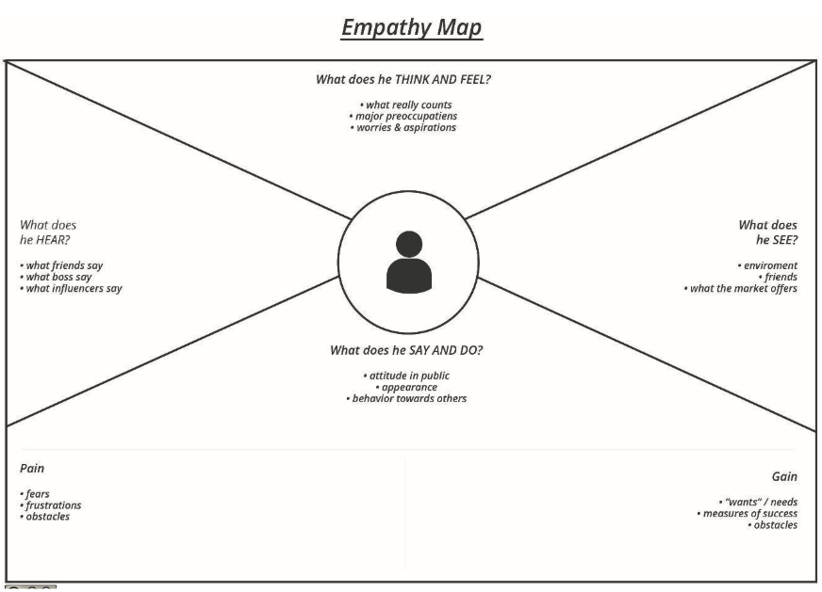

| Says | “I want to compare flight prices easily and book without hassle.” |
| --- | --- |
| Thinks | “What if the flight gets cancelled or prices drop after booking?” |
| Feels | Confused by inconsistent pricing, anxious about missing better options |
| Does | Searches across multiple platforms, takes screenshots to compare later |

**2.3 Brainstorming**

During the brainstorming session, the team proposed features like:

* Real-time search and filter by price, timing, and airline
* Price drop alerts and fare predictions
* Travel history and downloadable tickets
* Admin portal for managing operators and listings

**3. REQUIREMENT ANALYSIS**

**3.1 Customer Journey Map**

| Stage | Action |
| --- | --- |
| Awareness | User discovers the Flight Finder app via search or referral |
| Registration/Login | User signs up or logs in securely |
| Flight Search | Enters source, destination, date, and filters |
| Booking & Payment | Selects preferred flight, completes payment |
| Confirmation | Receives confirmation via email/SMS |
| Post-Trip Follow-up | Can review the trip, download invoice, or file support requests |

**3.2 Solution Requirement**

**Functional Requirements:**

* User registration and login (user/operator/admin)
* Search/filter flights based on various criteria
* Book/reschedule/cancel flights
* Secure online payment and ticket generation
* Admin dashboard for listing and user moderation

**Non-Functional Requirements**:

* Fast search and booking (<2 seconds)
* High uptime (99.9%)
* Secure data handling (SSL encryption, JWT tokens)
* Mobile-first design
* Scalable to support peak-time traffic

**3.3 Data Flow Diagram (Level 0 DFD)**

External Entities: User, Flight Operator, Admin  
Processes: Authentication, Flight Search, Booking, Payment, Notification  
Data Stores: User DB, Flights DB, Bookings DB, Payment Records

**3.4 Technology Stack**

* Frontend: React.js (Web), Flutter (Mobile – Future)
* Backend: Node.js with Express
* Database: MongoDB Atlas / PostgreSQL
* Authentication: JWT / Firebase Auth
* Hosting: Render / Vercel / AWS EC2

**4. PROJECT DESIGN**

**4.1 Problem-Solution Fit**

The platform solves the problem of inefficient and confusing flight bookings by offering an all-in-one flight search and booking system with real-time results, instant ticketing, and a user-focused interface.

**4.2 Proposed Solution**

A web and mobile-friendly application where:

* Travelers can easily search, book, and manage flight bookings
* Flight operators can upload listings and manage availability
* Admins monitor user activity and listings to ensure platform quality

**4.3 Solution Architecture**

Architecture Type: 3-Tier Client-Server Model

Layers:

* Presentation Layer: Responsive Web UI for users and operators
* Business Logic Layer: REST API for search, bookings, payments
* Data Layer: Flight listings, user profiles, booking records

**5. PROJECT PLANNING & SCHEDULING**

**5.1 Project Planning**

Agile methodology was adopted with sprints of 2–3 days each:

| Sprint | Duration | Deliverables |
| --- | --- | --- |
| Sprint-1 | 16 July – 17 July 2025 | Environment setup, auth system, landing page |
| Sprint-2 | 18 July – 19 July 2025 | Flight search and filter functionality |
| Sprint-3 | 20 July – 23 July 2025 | Booking module and profile management |
| Sprint-4 | 24 July – 26 July 2025 | Payment integration, notifications, testing |

**6. FUNCTIONAL AND PERFORMANCE TESTING**

**6.1 Performance Testing**

Tools Used:

* JMeter – for simulating concurrent users
* Postman – for testing RESTful APIs

Test Scenarios:

* Simulated 200 concurrent users
* Tested booking and search modules under load
* Validated average response time under traffic

Results:

* Flight search average load time: 1.4 seconds
* Booking success rate under load: 98%
* No significant bottlenecks or downtime detected

**7. RESULTS**

7.1 Output Screenshots:

HOME  PAGE :

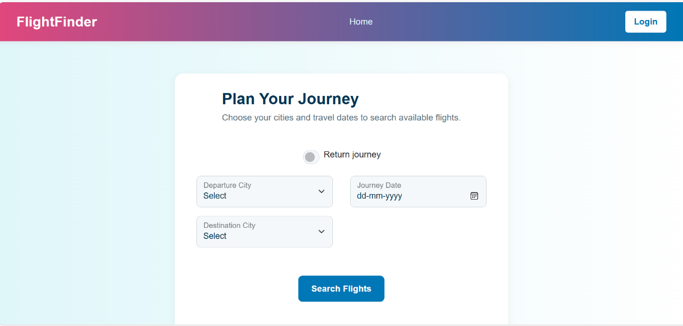

LOGIN PAGE:

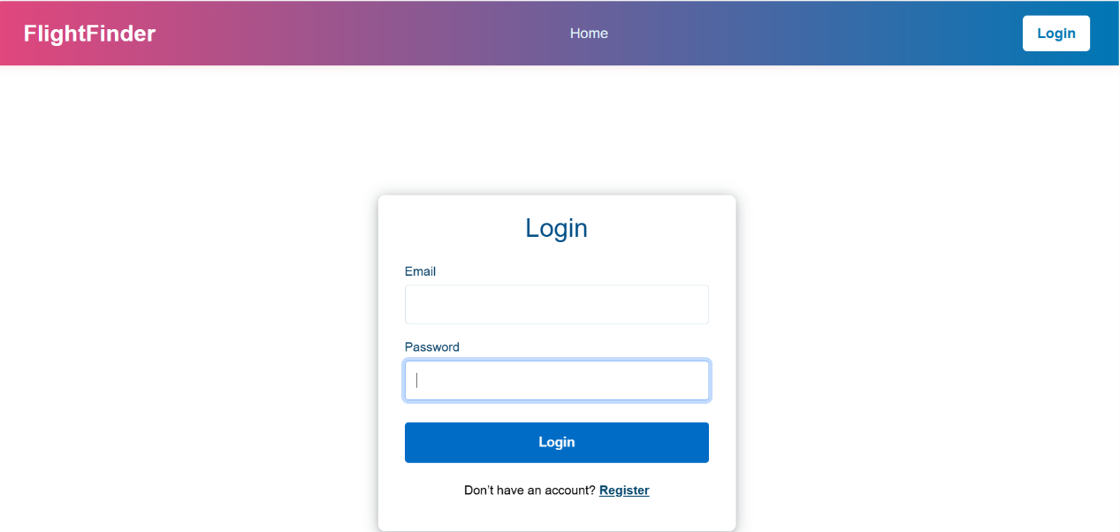

REGISTER PAGE :

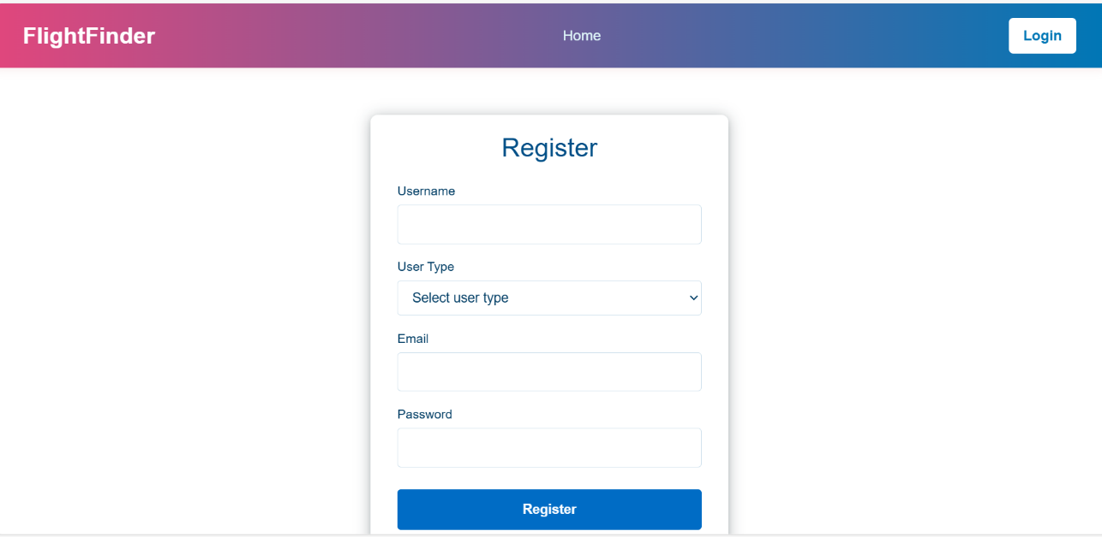

DASHBOARD:

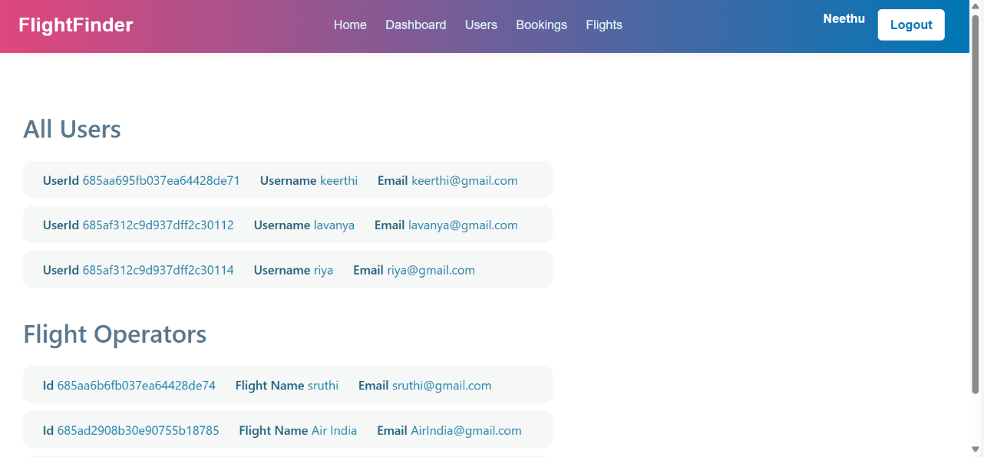

**8. ADVANTAGES & DISADVANTAGES**

**Advantages:**

* Saves time in searching and comparing flights
* Offers real-time pricing and availability
* Simplifies booking and payment processes
* Provides alerts for price drops and schedule changes

**Disadvantages:**

* Requires stable internet connectivity
* Initial development and API integration costs
* May involve learning curve for non-tech-savvy users

**9. CONCLUSION**

The **Flight Finder** project offers a modern and streamlined solution for booking flights across different airlines. It bridges the gap between travelers and airline operators by providing a centralized, efficient, and user-friendly platform. Leveraging real-time data, secure transactions, and responsive design, the system ensures high user satisfaction and operational efficiency.

**10. FUTURE SCOPE**

* Integration with real-time flight tracking APIs
* AI-based fare prediction and best-time-to-book engine
* Loyalty point system and frequent flyer support
* Multi-language and multi-currency compatibility
* Expansion to hotel and travel package bookings

**11. APPENDIX**

**Source Code:**  
https://github.com/PriyaBalireddy/flightfinder-navigating-your-air-travel-options